# **Introduction**

Discrete Mathematics deals with discrete objects. Discrete mathematics is the study of mathematical structures that are fundamentally discrete rather than continuous. On the other hand real numbers which include irrational as well as rational numbers are not discrete.

Discrete mathematics has been characterized as the branch of mathematics dealing with countable sets. Discrete mathematics is the study of mathematical relationships between distinct or individual parts. The concepts from discrete math are directly applicable to computing concepts. Discrete objects are those which are separated from each other. Rational numbers, integers, automobiles, people, houses, etc. are all discrete objects.

**Contents**

**Introduction** 1

**Part 1:-** 3

**Task 1.1** 3

**Task 1.2** 3

**Task 1.3** 4

**Task 1.4** 4

**Task 1.5** 5

**Task 1.6** 6

**Task 1.7** 6

**Part 2:-** 8

**Task 2.1** 8

**Task 2.2** 11

**Task 2.3** 12

**Graph coloring** 13

**Four color theorem** 13

**Five color throrem** 13

**Proof** 13

**Case 1** 13

**Case 2** 14

**PART 3:-** 15

**Task 3.1** 15

**Task 3.2** 15

**Task 3.3** 16

**Part 4:-** 17

**Task 4.1** 17

**Task 4.2** 18

**Groups** 18

**Task 4.3** 19

# **Part 1:-**

# **Task 1.1**

If A = {2, 3, 4, 5} B = {4, 5, 6, 7} C = {6, 7, 8, 9} D = {8, 9, 10, 11}, **perform** following **algebraic set operations.**

1. A ꓴ B = {2, 3, 4, 5, 6, 7}
2. A ꓵ B = {4, 5}
3. B ꓴ C = {4, 5, 6, 7, 8, 9}
4. C ꓵ D = {8, 9}
5. (A ꓴ B) ꓴ C = {2, 3, 4, 5, 6, 7, 8, 9}
6. A ꓴ (B ꓵ C) = {2, 3, 4, 5, 6, 7}
7. B ꓴ (C ꓴ D) = {2, 3, 4, 5, 6, 7, 8, 9, 10, 11}
8. A – B =

# **Task 1.2**

If A and B are two sets such that A ⊂ B, then what is A ꓴ B ?

Let’s take an example

A = {1, 2}

B = {1, 2, 3}

Every element of A is in B.

So , A is a subset of B

A ⊂ B

A ꓴ B = {1, 2} ꓴ {1, 2, 3}

= {1, 2, 3}

= B

# **Task 1.3**

Find the union, intersection and the difference (A - B) of the following pairs of sets.

1. A = The set of all letters of the word FEAST

B = The set of all letters of the word TASTE

A = {F, E, A, S, T}

B = {T, A, S, T, E}

A ꓴ B = {F, E, A, S, T}

A ꓵ B = {E, A, S, T}

Difference = {F}

1. A = {x : x ⋲ W 0 < × ≤ 11}

B = {x : x ⋲ W 5 < × < 11}

1. A = {x | x ⋲ N, x is a factor of 12}

B = {x | x ⋲ N, x is a multiple of 2, x < 12}

1. A = The set of all even numbers less then 14

B = The set of all odd numbers less then 13

A = {2, 4, 6, 8, 10, 12}

B = {1, 3, 5, 7, 11}

A ꓴ B = { }

A ꓵ B = {1, 2, 3, 4, 5, 6, 7, 8, 10, 11, 12}

Difference = {1, 2, 3, 4, 5, 6, 7, 8, 10, 11, 12}

1. A = {a, l, m, n, p}

B = {q, r, l, a, s, n}

A ꓴ B = {a, l, m, n, p, q, r, s}

A ꓵ B = {a, l, n}

Difference = {q, r, s}

# **Task 1.4**

Let ξ = {1, 2, 3, 4, 5, 6, 7} and A = {1, 2, 3, 4, 5} B = {2, 5, 7} show that

1. (A ∪ B)' = A' ∩ B'

(A ∪ B)' = ∅ {6} A' = {6, 7}

A' ∩ B' = {6} B' = {3, 1, 4, 6}

= (A ∪ B)' = A' ∩ B'

1. (A ∩ B)' = A' ∪ B'

(A ∩ B) = {2, 5}

(A ∩ B)' = {1, 3, 4, 6, 7}

A'ꓴ B' = {1, 3, 4, 6, 7}

= (A ∩ B)' = A' ∪ B'

1. (A ∩ B) = B ∩ A

(A ∩ B) = {2,5}

B ∩ A = {2, 5}

= (A ∩ B) = B ∩ A

1. (A ∪ B) = B ∪ A

(A ∪ B) = {1, 2, 3, 4, 5, 7}

B ∪ A = {1, 2, 3, 4, 5, 7}

= (A ∪ B) = B ∪ A

# **Task 1.5**

Given than A = {a, b, c, d}. Using the knowledge that you have in **determining the** **cardinality**, write down the power set of A.

Let A = {a, b, c, d}

|A| = 4

Where |A| represents cardinality of set A. now how one will find its power set. That’s too pretty simple. As already said power set is set of all subset of a given set. So one has to basically determine all the subset of set A.

{ }, {a}, {b}, {c}, {d}, {a, b}, {a, c}, {a, d}, {b, c}, {b, d}, {c, d}, {a, b, c}, {a, b, d} {b, c, d}, {a, c, d}, {a, b, c, d}

Now power set say

P = {{ }, {a}, {b}, {c}, {d}, {a, b}, {a, c}, {a, d}, {b, c}, {b, d}, {c, d}, {a, b, c}, {a, b, d} {b, c, d},

{a, c, d}, {a, b, c, d}}

Which clearly has 16 elements. So cardinality of power set A = 16 obviously this is tedious and cumbersome method to answer this problem.

# **Task 1.6**

**Determine the inverse of** following **functions using appropriate mathematical techniques.**

1. f(x) = 3x – 5

y = 3x – 5

x = (y + 5) / 3

y1 = (x + 5) / 3

1. g(x) = x3 – 7

y = x3 – 7

x =

y1 =

1. h(x) = (x + 2)/(x-3)

y = (x + 2) / (x - 3)

y(x - 3) = x + 2

x(y - 1) = 3y + 2

x = (3y + 2) / (y - 1)

y1 = (3x + 2) / (x - 1)

1. i(x) = √(x + 2)

y =

x = y2 – 2

# **Task 1.7**

**Prove** the followings using set identity. Use the knowledge of Venn diagram.

1. B ∪ (ø ∩ A) = B

RHS : B

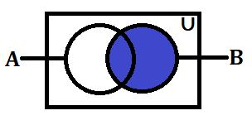

LHS : B ∪ (ø ∩ A)

1. (A ′ ∩ U) ′ = A

RHS : A

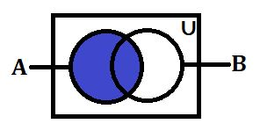

LHS : (A ′ ∩ U)

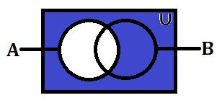

(A ′ ∩ U) ′

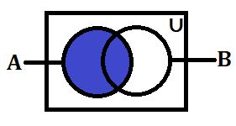

1. (C ∪ A) ∩ (B ∪ A) = A ∪ (B ∩ C)

RHS : A ∪ (B ∩ C)

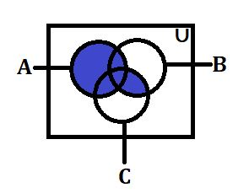

LHS : (C ∪ A)

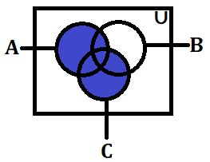

(B ∪ A)

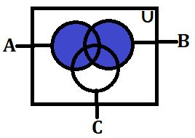

(C ∪ A) ∩ (B ∪ A)

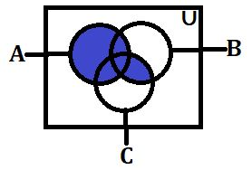

1. A ∩ (A ∪ B) = A

RHS : A

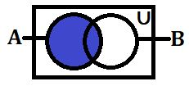

LHS : (A ∩ B′)

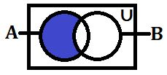

(A Ⴖ B) ᴜ (A Ⴖ B')



A ∩ (A ∪ B) = A

RHS : A



LHS : A Ⴖ (A ᴜ B)



# **Part 2:-**

# **Task 2.1**

**Find** the **shortest path** between A to Z **using Dijkstra's algorithm** in the diagram given below.

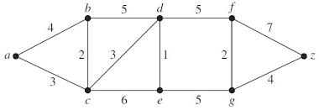

**Answer:-**



4 (a)

9 (a, c)

14 (a, c, d)

21 (a, b, d, f)

4 (a)

9 (a, c)

14 (a, c, d)

21 (a, b, d, f)



3 (a)

9 (a, c)

14 (a, c, e)

18 (a, c, e, g)

3 (a)

9 (a, c)

14 (a, c, e)

18 (a, c, e, g)



4 (a)

6 (a, b)

9 (a, b, c)

10 (a, b, c, d)

15 (a, b, c, d, e)

17 (a, b, c, d, e, g)

24 (a, b, c, d, e, g, f)

4 (a)

6 (a, b)

9 (a, b, c)

10 (a, b, c, d)

15 (a, b, c, d, e)

17 (a, b, c, d, e, g)

24 (a, b, c, d, e, g, f)



3 (a)

6 (a ,c)

7 (a, c, d)

12 (a, c, d, e)

16 (a, c, d, e, g)

3 (a)

6 (a ,c)

7 (a, c, d)

12 (a, c, d, e)

16 (a, c, d, e, g)

4 (a)

6 (a, b)

12 (a, b, c)

17 (a, b, c, e)

21 (a, b, c, e, g)

4 (a)

6 (a, b)

12 (a, b, c)

17 (a, b, c, e)

21 (a, b, c, e, g)





3 (a)

5 (a, c)

10 (a, c, b)

15 (a, c, b, d)

22 (a, c, b, d, f)

3 (a)

5 (a, c)

10 (a, c, b)

15 (a, c, b, d)

22 (a, c, b, d, f)



4 (a)

9 (a, c)

12 (a, b, d)

18 (a, b, d, c)

23 (a, b, d, c, e)

27 (a, b, d, c, e, g)

4 (a)

9 (a, c)

12 (a, b, d)

18 (a, b, d, c)

23 (a, b, d, c, e)

27 (a, b, d, c, e, g)



3 (a)

6 (a, c)

11 (a, c, d)

18 (a, c, d, f)

3 (a)

6 (a, c)

11 (a, c, d)

18 (a, c, d, f)



4 (a)

9 (a, c)

10 (a, b, d)

15 (a, b, d, e)

19 (a, b, d, e, g)

4 (a)

9 (a, c)

10 (a, b, d)

15 (a, b, d, e)

19 (a, b, d, e, g)



3 (a)

9 (a, c)

10 (a, c, e)

15 (a, c, e, d)

22 (a, c, e, d, f)

3 (a)

9 (a, c)

10 (a, c, e)

15 (a, c, e, d)

22 (a, c, e, d, f)



4 (a)

9 (a, b)

14 (a, b, d)

16 (a, b, d, f)

20 (a, b, d, f, g)

4 (a)

9 (a, b)

14 (a, b, d)

16 (a, b, d, f)

20 (a, b, d, f, g)



3 (a)

9 (a, c)

14 (a, c, e)

16 (a, c, e, g)

23 (a, c, e, g, f)

3 (a)

9 (a, c)

14 (a, c, e)

16 (a, c, e, g)

23 (a, c, e, g, f)

# **Task 2.2**

**Access whether an Eulerian and Hamiltonian circuit exists in** the below **undirected graphs**.

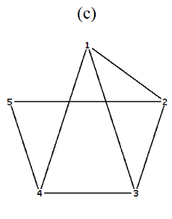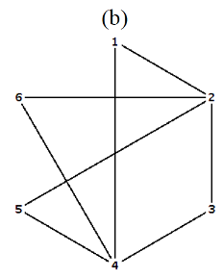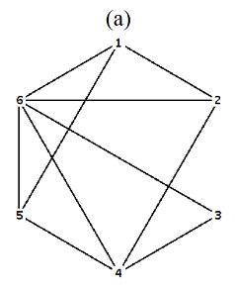

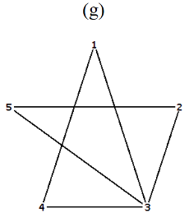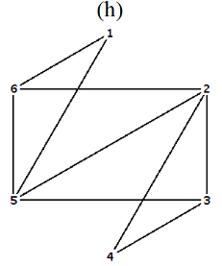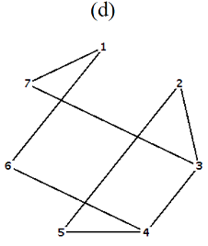

**Hamiltonian path**

**Hamiltonian path**

**Hamiltonian path**

**Hamiltonian path**

**Eulerian path**

**Eulerian path**

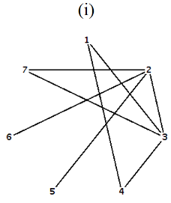

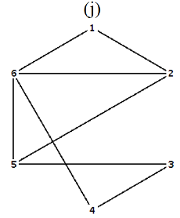

**Eulerian path**

**Hamiltonian path**

# **Task 2.3**

**Construct a proof of the Five Color Theorem**. Utilize the theory of the ‘chromatic number’.

# **Graph coloring**

Let G be a graph and C be a set of colors. Graph coloring finds an assignment of colors to the different nodes of G, so that no two adjacent nodes have the same color.

The problem becomes challenging when the |C| is small.

**Chromatic numbers**. The smallest number of colors needs to color a graph is called its chromatic number.

# **Four color theorem**

**Theorem**. Any planar graph can be colored using at most **four colors**.

It all started with map coloring-bordering states or counties must be colored with different colors. In 1852 an ex-student of De Morgan, Francis Guthrie, noticed that the counties in England could be colored using four colors so that no adjacent counties were assigned that same color. On this evidence he conjectured the four-color theorem. It took nearly 124 years to find a proof. It was presented be Andrew Appel and Wolfgang Haken.

# **Five color throrem**

Five-color theorem every planar graph is five-colorable.

## **Proof**

Proof by contradiction.

Let G be the smallest planar graph (in terms of number of vertices) that cannot be colored with five colors.

Let V be a vertex in G that has the maximum degree. We know that deg(V) < 6 (from the corollary to Euler’s formula).

## **Case 1**

Deg((V) ≤ 4. G-V can be colored with five colors.

There are at most 4 colors that have been used on the neighbors of V. there is at least one color then available for V.

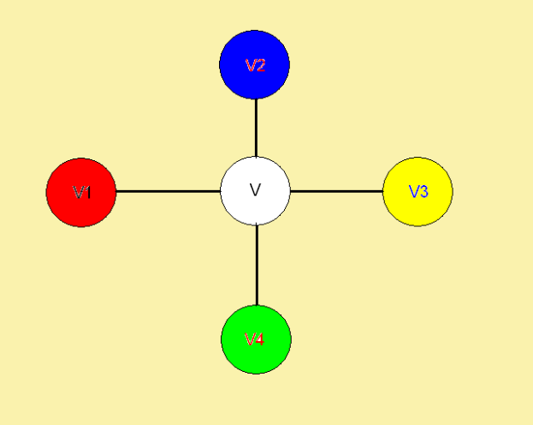So G can be colored with five colors a contradiction.

## **Case 2**

Deg((V) = 5. G-V can be colored with five colors.

If two of the neighbors of v are colored with the same color, then there is a color available for v.

So we may assume that all the vertices that are adjacent to v are colored with colors 1,2,3,4,5 in the clockwise order.

Consider all the vertices being colored with colors 1 and 3 (and all the edges among them).

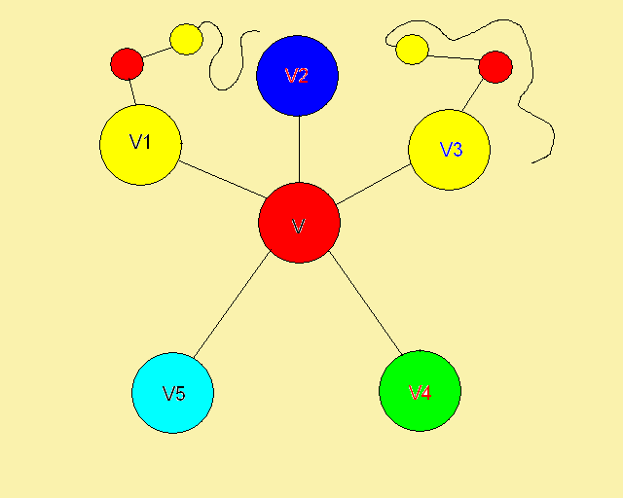

If this subgraph G is disconnected and v1 and v3 are in different components, then we can switch the colors 1 and 3 in the component with v1.

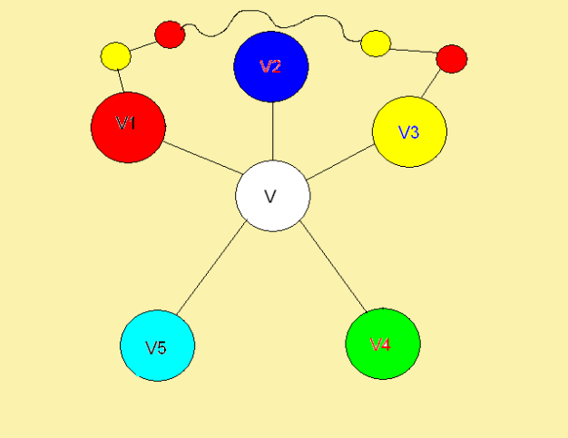

This will still be a 5-coloring of G-v. Furthermore, v1 is colored with color 3 in this new 5-coloring and v3 is still colored with color 3. Color 1 would be available for v, a contradiction.

Therefore v1 and v3 must be in the same component in that subgraph, i.e. there is a path from v1 to v3 such that every vertex on this path is colored with either color 1 or color 3.

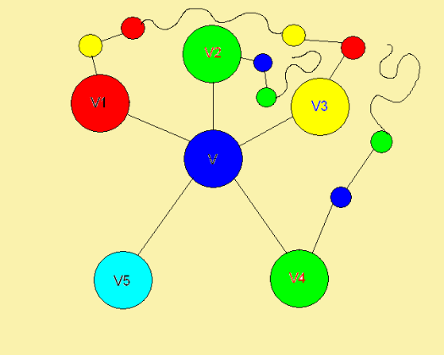

Now, consider all the vertices being colored with colors 2 and 4 (and all the edges among them). If v2 and v4 don't lie of the same connected component then we can interchange the colors in the chain starting at v2 and use left over color for v.

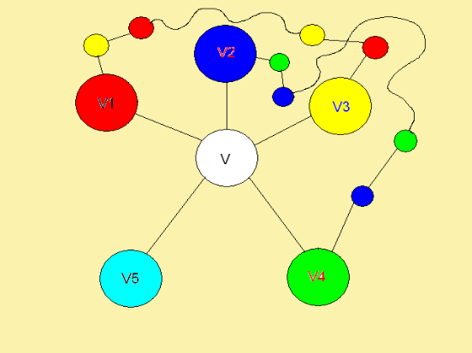

If they do lie on the same connected component then there is a path from v2 to v4 such that every vertex on that path has either color 2 or color 4.

This means that there must be two edges that cross each other. This contradicts the planarity of the graph and hence concludes the proof.

# **Part 3:-**

# **Task 3.1**

1. A – Timer

B – Sensor indicator

Q – Switched fan

|  |  |  |
| --- | --- | --- |
| A | B | Q |
| 0 | 0 | 0 |
| 0 | 1 | 0 |
| 1 | 0 | 1 |
| 1 | 1 | 0 |

1. Q = AB
2. 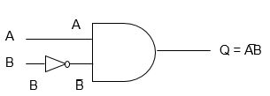

# **Task 3.2**

Simplify the following **Boolean equation using algebraic methods** and Boolean laws.

1. ACC + (A + A’) C + ABC

= AAC+C+ABC

= C (AC+1+AB)

= C (A (B+C) +) (A+1=1; OR law)

= C.1

= C

1. AA’ + BC + ABC

= 0+BC (1+A)

= 0+BC (A+1) (A+1=1; OR law)

= BC-1

= BC

1. (A + B + B) (A + A’) (AA + (B’)’) + CC’

= (A+B) (1) (A+B)+0

=(A+B) (A+B)

= (A+B)2

# **Task 3.3**

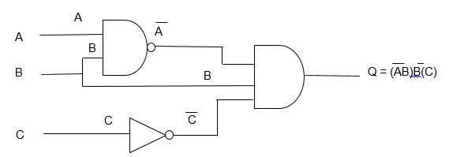

|  |  |  |  |  |  |  |
| --- | --- | --- | --- | --- | --- | --- |
| A | B | C | C | AB | AB | Q |
| 1 | 1 | 1 | 0 | 1 | 0 | 0 |
| 1 | 1 | 0 | 1 | 1 | 0 | 0 |
| 1 | 0 | 1 | 0 | 0 | 1 | 0 |
| 1 | 0 | 0 | 1 | 0 | 1 | 0 |
| 0 | 1 | 1 | 0 | 0 | 1 | 0 |
| 0 | 1 | 0 | 1 | 0 | 1 | 1 |
| 0 | 0 | 1 | 0 | 0 | 1 | 0 |
| 0 | 0 | 0 | 1 | 0 | 1 | 0 |

# **Part 4:-**

# **Task 4.1**

When considering the set of all the natural numbers (ℕ), show whether the mathematical operations of addition, subtraction, multiplication and division are:

1. Associative binary operation
2. Commutative binary operation

**NATURAL NUMBER :- {1,2,3…}**

**INTEGER NUMBER :- {-1, -2, -3, 0, 1, 2, 3…}**

**EXAMPLE:- ADDITION**

+ (a, b) = a + b

2 + 3 = 5

3, 2 belong to the set of natural numbers and the result 5 also belongs to the set natural numbers so addition is a binary operation.

**EXAMPLE:- SUBTRACTION**

-(a, b) = a – b

2 – 3 = -1

2, 3 belongs to the set of natural numbers and the result (-1) does not belong to the set of natural numbers so subtraction is not binary operation.

**EXAMPLE:- MULTIPLICATION**

*(a, b) = a * b

2 * 3 = 6

2, 3 belongs to the set of natural numbers and the result (6) also belong to the set of natural numbers so multiplication binary operation.

**EXAMPLE:- DIVISION**

% (a, b) = a % b

2 % 3 = 0.6

2, 3 belongs to the set of natural numbers and the result (0.6) does not belong to the set of natural numbers so division is not binary operation.

# **Task 4.2**

# **Groups**

**Definition:-** A group consists of a set A together with a binary operation on A with the following properties:-

1. x ∗ (y ∗ z) = (x ∗ y) ∗ z for all elements x, y and z of A (i.e., th operation ∗ is associative);
2. there exists an element e of A with the property that e x = x e = x for all elements x of A (i.e., there exists an identity element e for the binary operation ∗ on A);

* *∗*

1. given any element *x* of *A*, there exists an element *y* of *A* satisfying *x* ∗ y = y ∗ x = e (i.e., every element of A is invertible).

We see immediately from this definition that a group can be characterized as a monoid in which every element is invertible.

**Definition:-** A group (A, ∗) is said to be commutative (or Abelian) if the binary operation ∗ is commutative.

1. Validate that the **set** of non-zero real numbers with the **operation** **of multiplication** is a commutative **group**.

**EXAMPLE:- ADDITION**

2 + 3 = 5

2, 3, 5 are include in real numbers

**EXAMPLE:- SUBTRACTION**

2 – 3 = -1

2, 3 are include in real numbers but (-1) is not include in real number

**EXAMPLE:- MULTIPLICATION**

2 * 3 = 6

2, 3, 6 are include in real numbers

**EXAMPLE:- DIVISION**

3 / 2 = 1.5

3, 2, are include in real numbers but (1.5) is not include in real number

**Associative Binary Operation Semi Group**

**EXAMPLE:- ADDITION**

(2 + 3) + 5 = 2 + (3 + 5) = 10

**EXAMPLE:- MULTIPLICATION**

(2 * 3) * 5 = 2 * (3 * 5) = 30

# **Task 4.3**

An explanation that adequately explains why group theory is taught to computing students